Product Description

KTM Flash KTM Bench KTM OBD1.20 3 in 1 support 32 modules, which covers all functions of ktm flash, ktm bench and ktm obd.

**KTM Flash KTM Bench KTM OBD1.20 3 in 1  
  
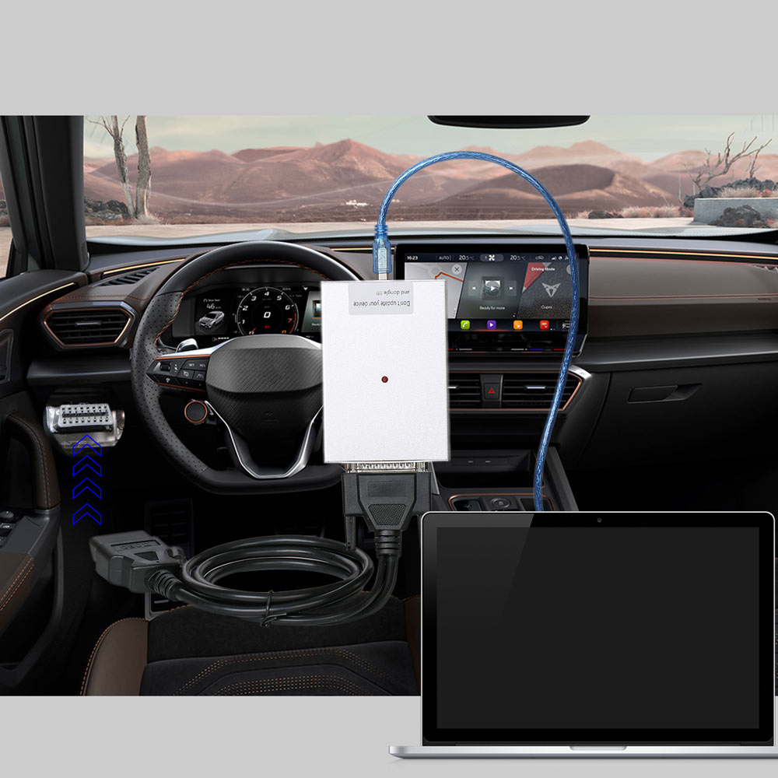  
  
Highlights:**  
  
1. ECU Chip Tuning for Cars via OBD  
2. Save around 400$ to get all functions  
3. Supports Volkswagen Audi read/write/clone  
4. Supports Honda, Toyota, Kia, Hyundai, some Ford, Volkswagen etc  
5. Covers all functions of ktm flash, ktm bench and ktm obd  
  
**Update Notice:**  
For customer who bought this machine, there are 2 ways to update to latest [**KTM200 67 in 1**](https://www.uobdii.com/wholesale/ktm200-69-in-1-ecu-programmer.html) or **[PCMtuner 67 in 1](https://www.uobdii.com/wholesale/pcmtuner-ecu-programmer.html)**:  
1. Return the old dongle back, pay $70 and bear the shipping cost back and forth.  
2. Buy a new [**KTM200 Dongle at $259**](https://www.uobdii.com/wholesale/ktm200-software-dongle.html)or **[PCMtuner Dongle at $199](https://www.uobdii.com/wholesale/pcmtuner-software-dongle.html)**directly without sending back the old one.  
  
**KTMFLASH KTMBENCH KTMOBD 3 in 1  ECU Connection Method:**  
  
1. Read and write ECU by Boot  
1. Read and write ECU on Bench (no need disaembling)  
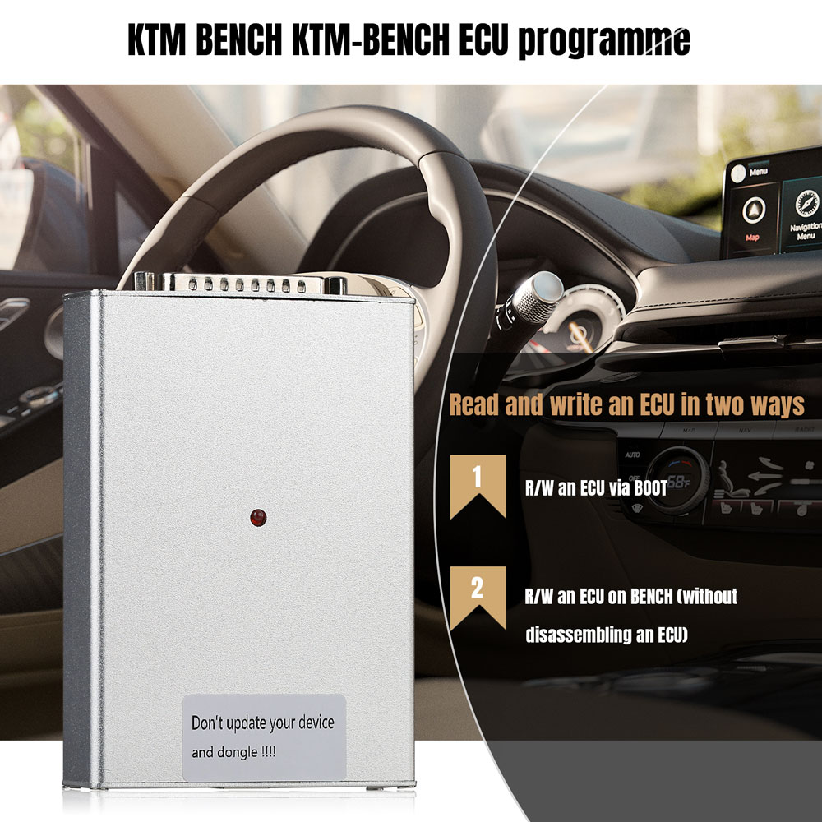

**EMT(ECU MARST TOOLS) Liet**

**Module 12**  
  
Honda/Acura CAN-bus

Honda: Honda PGM-FI Generic Read-Only

Honda: Honda AT/CVT/DCT Generic Read-Only

PGM-FI (Keihin SH7058/1MB)

PGM-FI (Keihin SH72543/2MB)

PGM-FI (Keihin SH72546/3.75MB)

PGM-FI (Keihin MPC5566/3MB)

PGM-FI (Keihin TC1782/2.5MB)

AT/CVT/DCT (Keihin 512KB)

AT/CVT/DCT (Keihin 1MB)

PGM-FI (Matsushita SH7058/1MB)

PGM-FI (Matsushita SH72543/2MB)

PGM-FI 2013+ (Matsushita SH72543/2MB) (Test)

PGM-FI (Panasonic TC179X/4MB)

AT/CVT/DCT (Matsushita 512KB) (Test)

Honda: PGM-FI (Continental MPC5554/2MB)

PGM-FI (Hitachi SH7058/1MB) (Test)

PGM-FI (Hitachi SH7059/1.5MB) (Test)

PGM-FI (Hitachi SH72543/2MB)

PGM-FI (Hitachi MPC5554/2MB) (Test)

AT/CVT/DCT (Hitachi SH72531/1280KB)

AT/CVT/DCT (Hitachi SH725x3/2048KB)

Reading, writing, checksum correction.

**Module 13**

Honda/Acura K-Line

Honda: Accord 7 2003-2005 (Matsushita RBA/RBB SH7055/512KB)

Honda: Accord 7 2006-2007/TSX 2004-2005 (Matsushita RBA/RBB SH7055/512KB)

Acura: TSX 2006 (Matsushita RBB A56-A62 SH7058/1MB)

Honda: Accord/CR-V/Element/Legend/Odyssey/Ridgeline (Keihin SH7058/1MB)

Honda: Element/Inspire (Keihin SH7055/512KB)

Honda: Legend/Acura TL 2005-2007 (Keihin RJA SH7058/1MB)

Honda: CR-V 2002/2005-2007 (Keihin PPA/PNL SH7058/1MB)

Honda: Fit/Jazz/Airwave 2001-2007 (Keihin OKI ML66Q592/192KB)

Acura: MDX 2003-2007 (Motorola RDJ SH7055/512KB)

Honda: Accord 7 USA (Motorola RCA SH7055/512KB SH7058/1024K)

Only writing, checksum correction. Stock files database included!

**Module 14**  
Petrol engines 1.6L, 2.0L, 2.3L, 2.5L Ford Mondeo 4

Ford Mondeo 4: 1.6L Sigma Ti-VCT 110/125PS (EMS2101)

Ford Mondeo 4: 2.0L Duratec HE (ESU312 Galaxy/S-Max 2006)

Ford Mondeo 4: 2.0L, 2.3L Duratec HE (ESU412/415)

Reading, writing, checksum correction.

Ford Mondeo 4: 2.5L Duratec I5 225PS (ME9.0)

Only writing, checksum correction. VBF writing and VBF to BIN conversion is supported!

**Module 19**

Kia/Hyundai

Kia/Hyundai: 1.4L, 1.6L (M(G)7.9.8)

Kia/Hyundai: 1.1L-1.6L (M(G)7.9.7)

Only writing, checksum correction.

Kia/Hyundai: 1.4L, 1.6L (ME17.9.11/12/13)

Kia/Hyundai: 1.4L, 1.6L (ME(G)17.9.21)

Kia/Hyundai: 1.6L, 3.0L (ME17.9.2/ME(D)(G)17.9.8)

Reading, writing, checksum correction.

**Module 20**

Ford Focus 2/Fiesta/Fusion (automatic transfer for VID area)

Ford Focus 2: 1.4L, 1.6L Duratec 85/100/115PS (SIM28/29)

Ford Focus 2: 1.8L, 2.0L Duratec HE 125/145PS (ESU131/411/418)

Ford Focus 2: 1.8L, 2.0L Duratorq Lynx/DW10C (SID202/SID206)

Ford Fiesta/Fusion: 1.4L, 1.6L Duratec 85/100PS (SIM210)

Ford Focus 2 ST: 2.5L Duratec I5 225PS (ME9.0)

Reading, writing, checksum correction.

Ford Kuga 1: 2.5L Duratec I5 200PS (ME9.0)

Writing, checksum correction.

**Module 21**

Ford USA (automatic transfer for VID area)

Mazda6 3.0L AJ 2003-2005

Escape, Explorer, Mazda CX9 -2009 (PCM150F)

Explorer, Mazda CX9 2010-2011/2012 (M799G)

Focus 2008-2011 (GreenOak/PCM190)

Escape, Mariner, Tribute 2009-2011 (9L8A)

Ford F350 6.0L (BlackOak/PCM122/448KB)

Expedition, Navigator 5.4L (Bosch ME9.8/2048KB)

F-150 5.4L (Bosch MEG9.8.1/2536KB)

Reading, writing, checksum correction

Mustang 2005-2009 (PCM170F)

Reading, writing.

**Module 26**

Mitsubishi Diesel CAN-bus

Denso Diesel (SH7058/SH7058S/1MB)

Reading, writing, checksum correction.

**Module 29**

Ford PWM (Ford VCM2 or Scanmatik is required)

Mondeo 3 1.8L, 2.0L, 2.5L, 3.0L Duratec HE (LEVANTA)

EEC-V 216K (EEC-V)

3.0L, 4.0L, 4.6L Duratec V6/V8 (PCM150)

Reading, writing, checksum correction

1.8L, 2.0L, 2.2L Duratorq TDCi (Visteon)

1.8L, 2.0L, 2.2L Duratorq TDCi (Delphi)

Reading, writing

**Module 30**

Kia/Hyundai SIM2K

2.0L, 2.4L (SIM2K-140)

2.0L, 2.5L (SIM2K-D160)

2.0L, 2.4L (SIM2K-141/142/341)

2.0L (SIM2K-C201)

2.0L, 2.0T (SIM2K-240/241/242/245)

Reading, writing, checksum correction.

**Module 32**

Ford Focus 3 2015, Ford Explorer 2016, Ford Kuga 2 2017

Ford Fiesta: 1.0L Ecoboost GTDI 100/125PS [C1BA] (MED17)

Ford Focus 3 2015: 1.0L Ecoboost 2015+ GTDI 100/125PS [DA6A] (MED17)

Ford Focus 3 2015: 1.5L Ecoboost 2015+ GTDI 150/180PS [FV6A] (EMS2510/EMS2511)

Ford Kuga 2 2017: 1.5L Ecoboost 2015+ GTDI 150/180PS [FV6A] (EMS2510/EMS2511)

Ford Explorer 2016: 3.5L Cyclone V6 Ti-VCT 249/294PS (2016)

Ford Mondeo 5: 1.5L Ecoboost GTDI MT 150/180PS (MED17)

Ford Mondeo 5: 2.5L Duratec Ti-VCT 150/171PS [GV6A] (EMS24XX)

Reading, writing, checksum correction.

**Module 33**

Ford EcoSport/Fiesta 2015+

2.0L Duratec HE 140PS (IAW 7GFR.HR)

Reading, writing, checksum correction.

1.6L Sigma Ti-VCT 85/105/110/122PS (EMS2211)

1.6L Sigma Ti-VCT USA [C1BA] (EMS2214)

Writing, checksum correction.

**Module 34**

Kia/Hyundai EDC15/EDC16

2.0L, 2.5L CRDI K-Line (EDC15C7)

2.0L, 2.2L, 2.5L CRDI K-Line Calibration (EDC16C39)

3.0L CRDI K-Line Calibration (EDC16CP34)

Reading, writing, checksum correction.

2.0L, 2.2L, 2.5L CRDI (EDC16C39)

3.0L CRDI (EDC16CP34)

Writing, checksum correction.

**Module 35**

Toyota/Lexus/Scion/Hino

76F0038/39/40/70/85, MPC565/SH72512/SH72544 CAN-bus

76F0038/39/40/50/70/85 GearBox CAN-bus

76F0038/39/40/50/70/85 HV Control CAN-bus

76F0004/23/38/39/40/70/85, MPC565 K-Line

Writing, checksum correction.

**Module 36**

Kia/Hyundai EDC17

1.6L, 2.0L CRDI (EDC17C08/TPROT3)

2.0L, 2.2L CRDI (EDC17CP14/TPROT3)

2.0L, 2.2L CRDI (EDC17CP14/TPROT11)

1.6L, 2.0L CRDI (EDC17C53)

2.2L CRDI (EDC17C57) (after unlocking with Module 53 or 71)

Reading, writing, checksum correction.

Module 40

Kia/Hyundai SIMK

2.0L, 2.7L K-Line (SIMK-41/43)

2.0L, 2.4L CAN (SIMK-43/SIM2K-47)

Reading, writing, checksum correction.

**Module 42**

Denso SH705X Bootloader

SH7055/SH7058(S)/SH7059 FLASH (512KB/1024KB/1536KB)

Reading, writing, checksum correction.

Mazda3 Z6 -2009 SH7055/SH7058 EEPROM (56)

Mitsubishi/Nissan/Subaru Diesel SH7058(S)/SH7059 EEPROM (86)

Subaru Metal-Case SH7055/SH7058 EEPROM (56)

Subaru Plastic-Case SH7058 EEPROM (86)

Subaru Plastic-Case SH7058S EEPROM (56)

Subaru Plastic-Case SH7058S EEPROM (86)

Suzuki Liana/Jimny SH7055 EEPROM (56)

Suzuki SH7055/SH7058 EEPROM (56)

Suzuki SH7058S EEPROM (56)

Volvo SH7058 EEPROM (56)

Opel 1.7L CDTI SH7058/SH7059 EEPROM (86)

Reading, writing.

**Module 46**

Toyota/Lexus/Scion/Hino 2 Generarion

76F0196/198/199/219 CAN-bus

Writing, checksum correction.

76F0196/198/199/219 P5-CAN-bus

76F0199 GearBox P5-CAN-bus

Reading, writing, checksum correction.

**Module 47**

Mitsubishi Gearbox CAN-bus

CVT Lancer X/ASX 1.8/2.0L, Outlander XL/3 2.0/2.4L (MH8104F/512KB MH8106F/1MB)

AT Pajero Sport (2010-), Lancer X 1.5/1.6L (MH8102F/512KB)

AT Outlander XL 3.0L (MH8104F/512KB)

Reading, writing.

TC-SST Getrag 6DCT470

Getrag 6DCT470 Boot (MICRO)

Getrag 6DCT470 Boot (EEPROM

Reading, writing, checksum correction.

**Module 52**

Kia/Hyundai Delphi MT38/86

2.7L, 3.3L, 3.8L (MT38/CAN)

Writing, checksum correction.

2.7L, 3.3L (MT38/K-Line)

2.7L, 3.3L, 3.8L (MT38/BSL)

3.3L, 3.8L, 5.0L (MT86)

Reading, writing, checksum correction.

**Module 53**

Infineon Tricore BSL

TC1762/TC1766 MICRO (1504KB)

TC1762/TC1766 EEPROM (32KB)

TC1792/TC1796 MICRO (2048KB)

TC1796 MICRO+EXT (4096KB/6144KB)

TC1796 EXT (2048KB/4096KB)

TC1792 EEPROM (64KB)

TC1796 EEPROM (128KB)

TC1738/TC1767 MICRO (2048KB)

TC1738/TC1767 EEPROM (64KB)

TC1797 MICRO (4096KB)

TC1797 EEPROM (64KB)

TC1797 MICRO+EXT (6144KB/8192KB)

TC1797 EXT (2048KB/4096KB)

TC1724/TC1728 MICRO (1536KB)

TC1724/TC1728 EEPROM (64KB)

TC1782/TC1784 MICRO (2560KB)

TC1782/TC1784 EEPROM (128KB)

TC1791/TC1793 MICRO (4096KB)

TC1791/TC1793 EEPROM (192KB)

TC1791/TC1793 MICRO+EXT (6144KB/8192KB)

TC1791/TC1793 EXT (2048KB/4096KB)

Delphi MT86 EEPROM (16KB)

Delphi CRD3.1 EEPROM (32KB)

Bosch, Siemens/Continental, Delphi ECUs, etc. Reading, writing, checksum correction for most ECUs.

Possible password reading for SIM2K-24x, Ford EMS22XX, Ford SID20X, Bosch, Bosch GPT, etc.

**Module 54**

Delphi DCM3.7/AP (SH72513/72543/72544)

Kia/Hyundai 2.5L CRDI (DCM3.7AP)

Opel/Chevrolet 2.0L, 2.2L CDTI (DCM3.7)

SsangYong 2.0L XDI (DCM3.7AP)

VAG 1.2L TDI (DCM3.7)

Great Wall/Haval 2.0L TD (DCM3.7)

Reading, writing, checksum correction.

**Module 55**

Kia/Hyundai Kefico/Denso

Kia/Hyundai 2.5L CRDI (SH72546)

Reading, writing, checksum correction.

**Module 57**

SIMOS 8/10/11/PCR2.1

2.8L V6 FSI (SIMOS8.1)

3.2L V6 FSI (SIMOS8.2)

Reading, writing, checksum correction.

3.0L V6 TFSI (SIMOS8.3)

3.0L V6 TFSI (SIMOS8.4)

3.0L V6 TFSI (SIMOS8.5)

Virtual reading, writing, checksum correction.

2.8L V6 FSI (SIMOS8.6)

Reading, writing, checksum correction (map area reading/writing after unlocking in BSL!)

SIMOS8.6 (EEPROM/UNLOCK/BSL)

Reading, writing (EEPROM reading/writing, ECU unlocking)

1.2L TSI (SIMOS10)

1.2L MPI (SIMOS11)

Virtual reading, reading, writing, checksum correction.

1.6L TDI (PCR2.1)

Reading, writing, checksum correction (map area reading/writing after unlocking in BSL!)

PCR2.1 (EEPROM/UNLOCK/BSL)

Reading, writing (EEPROM reading/writing, ECU unlocking).

**Module 58**

VAG DSG/CVT

DQ200MQB/G2 (0CW)

DQ250MQB (0D9)

VL381/DL382 (0AW/0CK)

DL501/G2 (0B5)

DQ200 (0AM)

DQ250E/F (02E)

VL300/V30 (01J/0AN)

Writing, checksum correction

DQ200/MQB/G2 Boot (EEPROM)

DQ250E/F/MQB Boot (EEPROM)

DL501/G2 Boot (EEPROM)

VL381 Boot (EEPROM)

DL382 Boot (EEPROM)

Reading, writing

DQ200/MQB/G2 Boot (MICRO)

DQ250E/F/MQB Boot (MICRO)

VL381 Boot (MICRO)

DL501/G2 Boot (MICRO)

DQ500 (0BH/0BT)

VL300/V30 BSL (FLASH)

VL300/V30 BSL (EEPROM)

DQ250C (02E)

DL382 Boot (MICRO)

Reading, writing, checksum correction.

**Module 61**

Kia/Hyundai CPGDSH/CPEGD

1.6L (CPGDSH2.24.1/CPEGD2.20.1/UDS

Reading, writing, checksum correction.

**Module 62**

Ford/Getrag 6DCT450

PowerShift TCM (6DCT450)

PowerShift 6DCT450 Boot (MICRO)

PowerShift 6DCT450 Boot (EEPROM)

Reading, writing.

**Module 63**

Renault DC4

EDC DC4 Gearbox (TC1766/1506KB)

Reading, writing, checksum correction.

**Module 66**

Honda Bosch

PGM-FI (Bosch EDC17CP06/EDC17CP16/2MB)

Writing, checksum correction.

PGM-FI (Bosch EDC17CP50/4MB) [Unlocked]

PGM-FI (Bosch EDC17C58/4MB) [Unlocked]

PGM-FI (Bosch EDC17C72/2.5MB) [Unlocked]

PGM-FI (Bosch MED17.9.3/4MB) [Unlocked]

PGM-FI (Bosch ME17.9.55/1.5MB) [Unlocked]

Writing after unlocking with Module 53 or 71, checksum correction.

**Module 71**

Bosch MEDC17 Bootloader

MEDC17 (TC1762/1766/1792/1796)

MEDC17 (TC1724/1728/1767/1782/1784/1797)

MEDC17 (TC1791/1793) FLASH

Reading, writing, checksum correction.

MEDC17 (TC1762/1766/1792/1796) EEPROM

MEDC17 (TC1724/1728/1767/1782/1784/1797) EEPROM

MEDC17 (TC1791/1793) EEPROM

Reading, writing.

MEDC17 BSL PASSWORD

Reading.

Module 72

Mazda Gen 4

1.5L, 2.0L, 2.5L SKYACTIV-G P5/PA/PE/PY MY2019 (Mitsubishi) [PYFA]

1.5L, 2.0L, 2.5L SKYACTIV-G P5/PA/PE/PY MY2019 (Denso) [PYFB]

Reading, writing, checksum correction.

**Module 73**

Ford MG1

Ford F-150: 3.5L Ecoboost V6 (MG1CS015) [HL3A]

Ford Fiesta 8: 1.5L Ecoboost MT (MG1CS016) [JX6A]

Ford Focus 4: 1.0L, 1.5L Ecoboost MT (MG1CS016) [JX6A]

Ford Focus 4: 1.5L Ecoboost AT (MG1CS017) [JX6A]

Ford Mustang 6: 2.3L Ecoboost (MG1CS017) [JR3A]

Ford Mustang 6: 5.0L Coyote V8 (MG1CS019) [JR3A]

Reading, writing, checksum correction

**Module 74**

Toyota/Lexus Gen 3

R7F701202 P5-UDS

Reading, writing, checksum correction  
  
**Software Display:**  
  
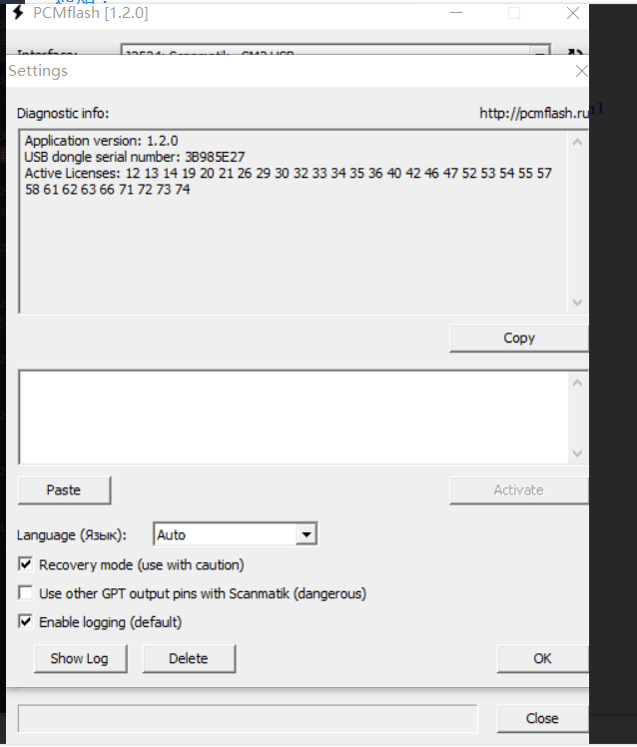  
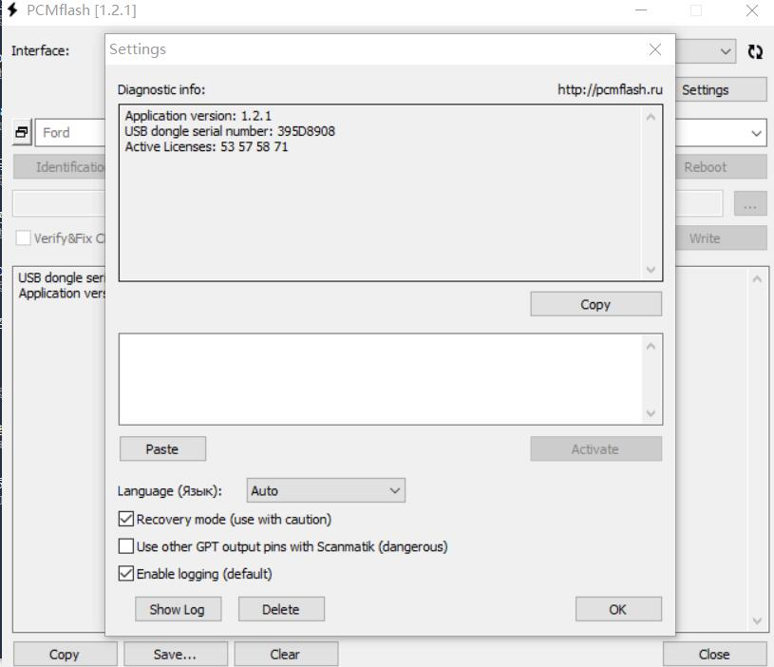

**Package includes:**

1set x KTM FLASH KTM BENCH KTM OBD1.20 3 in 1